NOVAC Technology Solutions

Software Requirement Specification
For
Download Policy Schedule through Website

Revision History

Version No. | Date | Reason For Changes | Author | Reviewer | Approver
0.1 | 10-Mar-2025 | Draft document to download the Policy schedule through website | PL.Nijanthan | M. Arunkumar | Mr. Manoj Josep
1.0 | 27-Mar-2025 | Baseline of draft version 0.1 | PL.Nijanthan | M. Arunkumar | Mr. Manoj Josep

Table of Contents
1. Introduction 4
1.1 Purpose 4
1.2 Project Scope 4
1.2.1 Features for Future Releases 4
1.3 References 4
1.4 System Description 4
2. Functional Requirements 4
2.1 Functional Overview 4
2.2 Download Policy PDF 4
2.2.1 Accounting Impact 8
2.2.2 Other Impacts 8
2.3 Assumptions and Dependencies 9
3. Interface Requirements 9
3.1 Internal Interfaces 9
3.1.1 Hardware Interface 9
3.1.2 Software Interface 9
3.1.3 Communication Interface 9
3.1.4 External Interfaces 9
3.1.4.1 Hardware Interface 9
3.1.4.2 Software Interface 9
3.1.4.3 Communication Interface 9
3.2 Operating Environment Requirement 9
3.2.1 Hardware Requirements 9
3.2.2 Software Requirements 9
3.2.3 Network Requirements 9
3.2.4 Operational scenarios: 10
3.3 Non Functional Requirements (NFR) 10
3.3.1 Reliability 10
3.3.2 Performance 10
3.3.3 Security 10
3.3.4 Usability 10
3.3.5 Other Requirements 10
3.4 Open Issues 10
3.5 Acceptance Criteria 10
4. Appendix A 10

Introduction

Purpose
The purpose of this requirement is to provide the option to Insured person to download the Policy schedule document based on the corresponding input details on the website.

Guidelines, circulars, instructions and directions released from time to time by Philippines Insurance council .

Project Scope
To provide the provision to Insured to download the Policy schedule for Individual Motor policy for the corresponding input parameter through website.

Features for Future Releases

References

System Description
The SGI Philippines website should have a facility to download the Policy schedule in PDF format for the Individual Motor Policies.

Functional Requirements

Functional Overview
The SGI Philippines website should provide a facility to download the Policy Schedule PDF for Individual Motor Policies. However, the system should restrict the generation of the Policy Schedule for Motor Fleet Policies and Non-Motor Policies.

Download Policy PDF
- The Policy Schedule PDF download facility should be applicable only for Individual Motor Policies. It should not be applicable for Motor Fleet Policies or Non-Motor Policies.
- The system should display the "Download Policy PDF" option when the user clicks on the Support button. (Refer to the attached screenshot for reference.)
- Upon selecting "Download Policy PDF", the user should be redirected to the corresponding screen. The system should allow users to download the Policy Schedule PDF based on the provided policy input parameters. (Refer to the attached screenshot for input parameter details.)
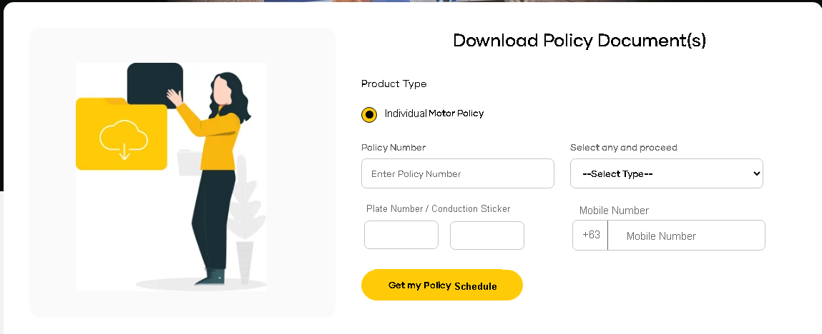
- On clicking the “Get my Policy Schedule” without input parameter details then system should display the error message for the corresponding fields in the screen. Refer the below screen shot.
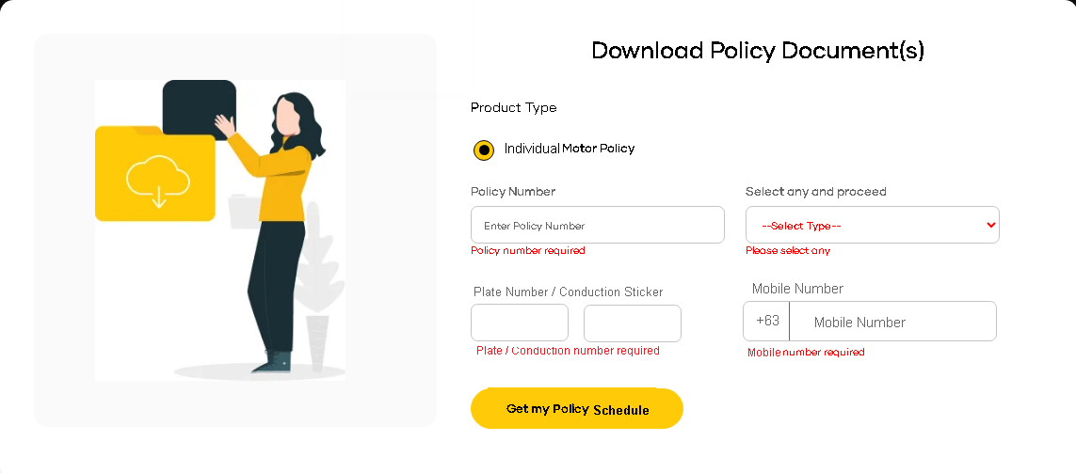

- On clicking the “Get my Policy Schedule” button, if no records match the provided input values, the system should display an error message as“No records found!!”. Refer the below screen shot.

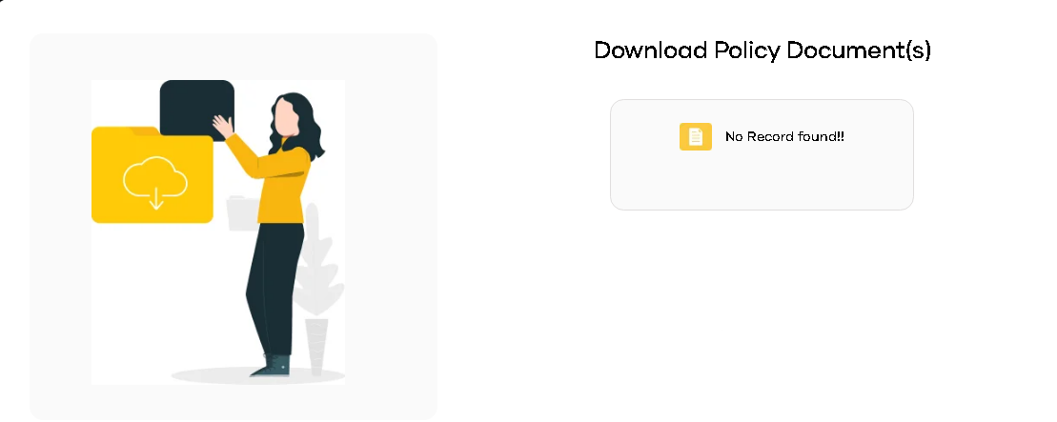

- On clicking the “Get my Policy Schedule”, if matching records are found, the system should display a screen allowing the user to download the policy schedule.
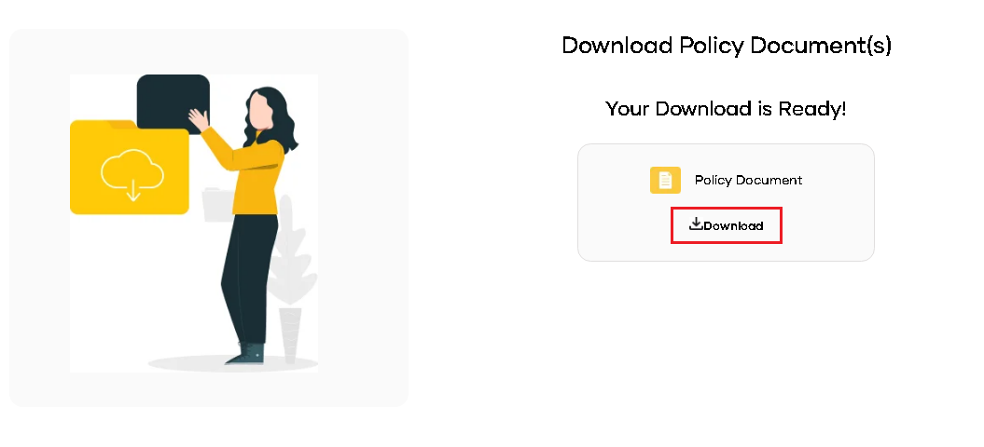

- Upon clicking the "Download" button, the system should generate and download the policy schedule in PDF file in the browser. Refer the below screen shot.

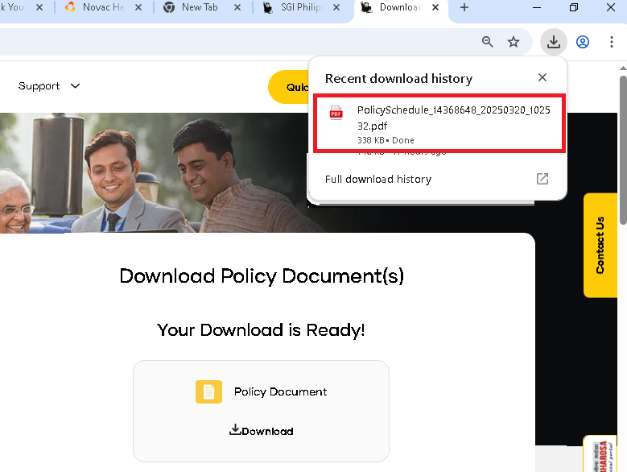

- The system should generate and download the Policy Schedule excluding the following pages such as Statement of Account, Certification Page and Warrantee Clauses. Refer the below screen shit.

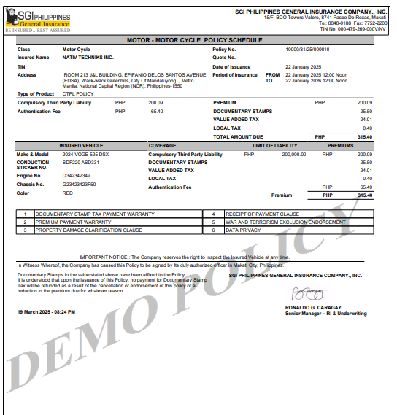

Sl. No. | FIELD NAME | FIELD TYPE | INPUTS | VALIDATION
Input Parameters for Policy Schedule Download
1 | Individual Motor | Radio Button |  | - The system should automatically set the radio button selection to "Individual Motor" by default.  - The selected radio button should be frozen and non-editable, preventing users from modifying the selection
2 | Policy Number | Free text |  | - It is a user enterable  - It is a mandatory field  - The system should allow to input the alphanumeric and special character
3 | Select any one | Drop down | - Plate no / Conduction Sticker  - Engine Number  - Chassis Number | - User selection  - It is a mandatory field
4 | Mobile Number | Numeric |  | - The system should default the country code to "+63", which should be a fixed value and cannot be modified.  - The field should be user-enterable and mandatory.  - The system should only accept numeric values without decimals.  - The input must strictly capture a 10-digit number.
5 | Get my policy schedule | Button |  | - Upon clicking the button, the system should validate the required input parameters. If any mandatory input is missing, the system should display the corresponding error message on the screen.  - If all required inputs are provided but no matching data is found in the database, the system should display an error message: "No records found!!".  - If a matching record exists in the database, the system should generate and download the policy schedule in the browser.

Accounting Impact

Other Impacts

Assumptions and Dependencies
<Not Applicable>

Interface Requirements
<Not Applicable>

Internal Interfaces

Hardware Interface
<Not Applicable>

Software Interface
<Not Applicable>

Communication Interface
<Not Applicable>

External Interfaces

Hardware Interface
<Not Applicable>

Software Interface
<Not Applicable>

Communication Interface
<Not Applicable>

Operating Environment Requirement
<Not Applicable>

Hardware Requirements
<Not Applicable>

Software Requirements
<Not Applicable>

Network Requirements
<Not Applicable>

Operational scenarios:
<Not Applicable>

Non Functional Requirements (NFR)

Reliability
<Not Applicable>

Performance
<Not Applicable>

Security
<Not Applicable>

Usability
<Not Applicable>

Other Requirements
<Not Applicable>

Open Issues
<Not Applicable>

Acceptance Criteria
- Functional testing will be executed by internal testing team, and the same will be delivered to client for UAT.

Appendix A
Not Applicable

